**Assignment_5**

**Name:Gali Sai Jayasri**

**Trainer:Harshee**

**Course:Python &Machine Learning**

**Date:6/06/2022**

**QUESTION_1:**



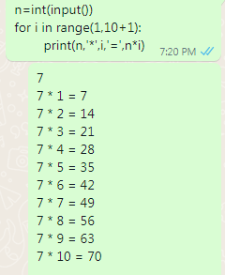

**QUESTION_2:**

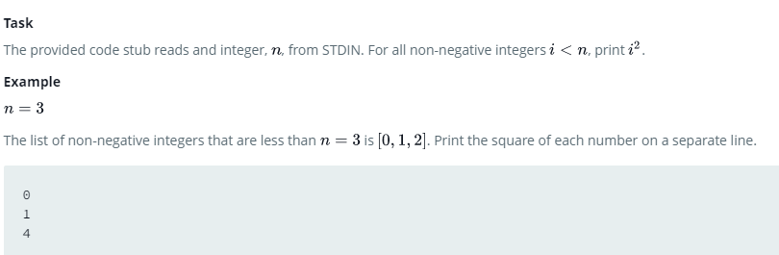

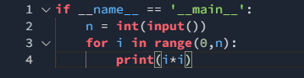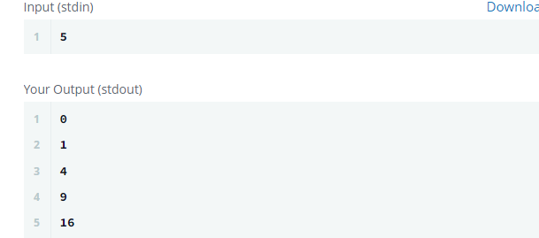

**QUESTION_3:**

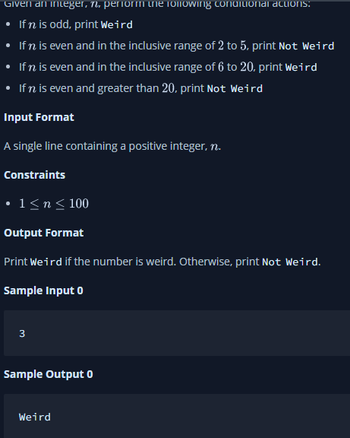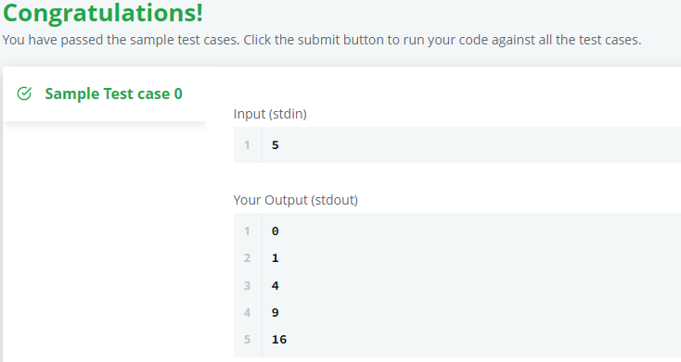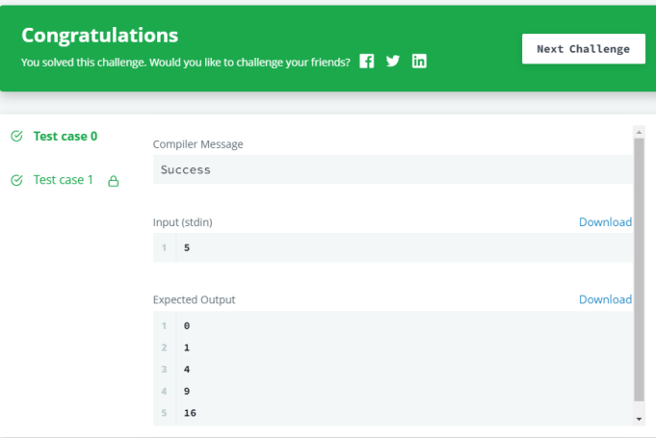

**QUESTION_4:**

**https://www.hackerrank.com/challenges/whats-your-name/problem?isFullScreen=true**

